Name: _______________________________________________________________ Pd: _______________
The Interesting Life of Olaudah Equiano
(pg. 80-84)
Step 1: Marking the Text
Directions: Mark Part 1 of the “The World On the Turtle’s Back”, looking for the following specific things:
- Circle all the Vocabulary Words from this week’s Vocab and write the synonyms by them
- Highlight or Underline all of the Imagery found throughout the story
  - Remember Imagery includes: Touch, Taste, Sight, Sound, Smell

Step 2: Plot Based Questions
Directions: Answer the following questions as they pertain to each portion of the story “The Interesting Life of Olaudah Equiano”
*Each of the numbers in (parenthesis) indicate page you may find the answer in*

- What did Equiano first see when he arrived on the coast? How did he feel about it initially? (pg. 80)

- What world did Equiano believe he was in now? What did he believe they were going to do to him? (pg. 80)

- What happened to Equiano when he looked around at all the black people on the deck? (pg. 82)

- What did Equiano believe the “white men” were going to do to him? (pg. 82)

- When Equiano’s nostrils were hit with the stench when he was put under the deck, what did Equiano become? What did he wish for? (pg. 82)

- What did they do with the white man’s body that they flogged unmercifully? (pg. 83)

- Where did Equiano believe that the people lived? How come they did not see them before? (pg. 83)

- What did they believe about how the people made the vessel go, or stop? (pg. 83)

- Why was Equiano allowed to stay on deck? (pg. 83)

- What kinds of sounds did Equiano hear coming from below deck? (pg. 83)

- What did the slave traders do with the fish once they had their fill of eating? (pg. 83-84)

- How were the slaves sold? Describe the process. (pg.84)

- What happened to the slave brothers that came over in the same vessel together? (pg. 84)

- What question did Equiano ask of the “Christian” slave owners who were buying them? (pg. 84)

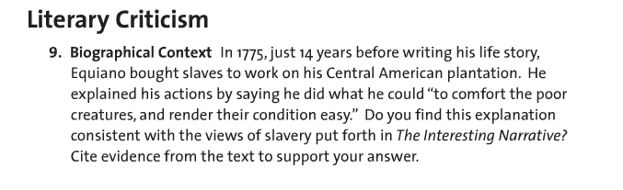Step 3: Follow Up Question
Directions: Answer the following questions in 1 paragraph (5-7 sentences) using at least 2 pieces of textual evidence. Use line numbers to cite the examples.

