Cesar Chavez High School
Plan for Student Success

Teacher: Mr. Salvador Lopez Course: English 5-6 Room: 5105
E-mail: slopez2@phoenixunion.org Phone #: (602)764-4000 Ext. 64167
Class Website: www.cchslopez.weebly.com
Course Description:
English 5-6 is the next course in the series for required English credits beyond English 1-2 and 3-4. Instruction builds upon the reading, writing, listening, speaking and critical thinking foundations established in 9th and 10th grade. Included is the study of American literature collections related to personal experiences. A variety of essay writing strategies are taught and implemented. Active listening and speaking are practiced in formal and informal situations. A variety of multimedia presentations are evaluated for social and cultural messages and connections with text. Students will be able to identify various literary terms throughout this course, while using them in their own writing. Students will examine various literary terms within several pieces of literature, including short stories, non-fiction and fiction pieces, and poetry. Students will also be asked to learn, facilitate and use a variety of education technology to further build their repertoire of skills in preparation for college, career and life.

Expectations for Students

- Be on time & Prepared
- Respect others and their right to learn
- Respect all materials and equipment
- No food or drinks, unless it is a closed container
- No cursing or vulgar or offensive language

- No Electronic Devices (cell phones, iPods, etc.) unless otherwise specified. (See CCHS Electronic Devices Policy for further details)
  - 1st Violation – Device held until lunch or afterschool
  - 2nd Violation – Device is picked up and taken to the Dean

Tools for Success
- Class Website: www.cchslopez.weebly.com
  - All pertinent information for the class can be found on the website
- McDougall Littell American Literature Textbook
- All students are required to have a GMAIL account, which we will create in class
  - Password chosen by the student
  - Gives access to Educational Technology websites to be utilized (see Educational Technology for more info)
- Cesar Chavez High School Agenda
- There will be class novel(s) that will be required for our class that must be purchased
  - Novels are available for purchase in our CCHS Bookstore (these are wholesale prices for brand new books)
  - If there is an issue purchasing our books, please get in contact with Mr. Lopez

Attendance Policy
“Absent” is defined as nonattendance in an assigned class or activity for more than one-half of the period. (PUHSD Governing Board Policy J-1561 JHR)
“Tardy” is defined as not being in the assigned class or activity when the tardy bell has finished ringing. (PUHSD Governing Board Policy J-1561 JHR)
REMEMBER – Once a students is beyond 12 absences, excused or unexcused, they MAY NOT receive credit for the course
Grading Policy
A weighted system for each quarter’s work is as follows:
- Homework and in-class assignments = 35%
- Essays/projects = 35%
- Quizzes/tests = 30% - CRT’s/Final Exams count for 10% of the Semester Grade*

A = 100 – 90 % B = 89 – 80 % C = 79 – 70 % D = 69 – 60 % F = below 60 %
Students and parents can access grades any time throughout the semester via StudentVue/ParentVue from the district website. Class information can be accessed on the teacher’s webpage by going to the Chavez home page and searching for my name in the top right hand box and scrolling down to the Home Teacher Page.
- Accommodations and modifications will be made according to IEP’s and 504 plans.

Make-Up Policy & Advisory Period
Every three weeks, a progress report will be sent home through e-mail and postal mail. At the end of each three week interval, students must have all late work submitted. After the three weeks, no make-up work will be accepted unless otherwise discussed or specified with valid excuse. Valid excuse includes personal/familial circumstances, excused absence, personal injury, etc. that is reported to the CCHS front office along with Mr.Lopez. All assignments are uploaded to the classroom website: www.cchslopez.weebly.com , so absent students can stay up to date with current classwork.

Each day late, a student will lose 10% of points earned, up to 50%. So a 100pt assigned will lose 10pts a day, up to 50pts. After the progress report day, student will not be able to submit that assignment.

During the Advisory Period students will be given an opportunity to complete/make-up work from all of their classes. During the Advisory Period teachers will have the opportunity to call out students and bring them back to their class for extra help. The Advisory Period means that students have 30-40 minutes built in to their schedules during the day to work on any homework they may have. This means there is no excuse for not having enough time to do work.
Attendance is still imperative to passing our class.

Title I Program
Academic tutoring and test preparation is available to all students. Additional support for passing classes and graduating on time is the intent of these services. Support through Title I funding is available in the areas of: math, reading and English. If interested, please contact Principal Georgia or Assistant Principal for Instruction Gillespey, or for additional information at 602-764-4010 or 602-764-4011.

Multimedia Presentations & Films
It is my belief that there are a great variety of learners, and our students are increasingly becoming visual learners. To support the lessons given, I will be showing a variety of films (not in their entirety, but portions) to further the understanding of particular works of literature as well as concepts. Some of these films may be rated R, but are rated as such because of the content of the entire movie. I will be showing only portions of the movie. If you are uncomfortable with your student watching these particular movies, an alternate assignment may be given in its place with no consequence to your student. Please contact me with any further concerns dealing with these presentations.

Educational Technology
In a constantly advancing world, technology & computers have become a staple in our daily lives, especially the internet. That is increasingly becoming the case in education as well. It is almost impossible to be successful at the college and university level without being familiar with educational technology. As Juniors, our students need to become more familiar on how to use technology to their advantage. Students in this English 5-6 course will be taught Digital Citizenship and how to use technology for more than just social media, but to advance their future. A great portion of the class will be presented online so students may become accustomed to online work that is becoming more and more of the norm in colleges/universities. If a student does not have access to the internet at home, the computer labs at the CCHS Library are open 7:00am to 6:45pm unless otherwise specified.
*If you are concerned about your student’s ability to work online…please contact me as soon as possible*

As part of their online classwork, every student is required to create a GMAIL ACCOUNT to be their professional e-mail and login for a variety of programs we will be utilizing. Here is an example of websites we will be utilizing:

- Study Island - www.studyisland.com
- Google Applications – www.google.com
- CCHS Website – www.chavezhs.org

- Remind 101 – www.remind.com – This program is especially important. This is an excellent way for Mr. Lopez & Ms. Alonzo to stay in contact and keep you and your student updated on information. It is a text message application in which a mass text message is sent to everyone in the group. Group member’s numbers are not kept and group members cannot reply to the messages. Please follow the directions below to join the Parent Group.

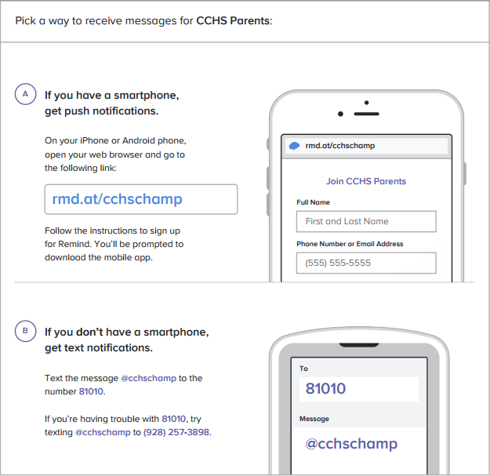
DUE BY FRIDAY
Plan for Student Success

Print Student First and Last Name: ____________________________________________________

I, (student signature) ____________________________________, have read and understand the Plan for Student Success. I will support and follow all procedures and guidelines for the English 5-6 Classroom.

I, (parent/guardian) _____________________________________, the parent/guardian of ___________________________ have read and support the Plan for Student Success.

Parent/Guardian, please provide your Name, Best Phone Number to reach you and Best E-mail to reach you:

Name: ___________________________ __________ Phone # (____) _____ - ________
E-Mail: _______________________________@___________________

Name: ___________________________ __________ Phone # (____) _____ - ________
E-Mail: _______________________________@___________________

Please sign and return this form to Mr. Lopez ASAP. Thank you.

