Patrick Henry's
"Speech at the Virginia Convention"

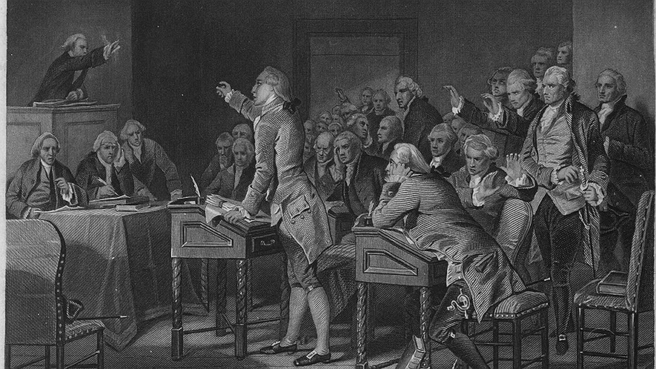
An engraving of Patrick Henry addressing the Virginia Assembly in 1765. It was published 1867. Photo: H.B. Hall after Alonzo Chappel,
BACKGROUND
In the spring of 1775, delegates from the state of Virginia could not agree whethere to press for a peaceful solution with Britain or to prepare for war. Patrick Henry introduced resolutions calling for military preparedness. After politely listening to his colleagues objections to armed rebellion, he rose to deliver his impassioned appeal.

¹ No man thinks more highly than I do of the patriotism, as well as abilities, of the very worthy gentlemen who have just spoken to the House. But different men often see the same subject in different ways. Therefore, I hope you will not think me disrespectful to those gentlemen if I speak my feelings freely and without limits. This is no time for formality.
The question before the House is very important to this country. I consider it nothing less than a question of freedom or slavery. Because the importance of the subject is so great, we should debate it with great freedom. It is only in this way that we can hope to arrive at truth. We must fulfill the great responsibility which we have to God and our country. If I kept my opinions to myself at a time like this, for fear of hurting someone, I would feel I was committing a crime of betraying my country. I would also feel disloyal to God, who I honor more than all earthly kings.
Mr. President, it is natural for a man to allow himself to have hopes. However, sometimes it is a mistake to hope for
¹⁰ something. We are likely to shut our eyes to keep out a painful truth. We are like the men in the Greek myth, who were lured in by the beautiful song of the Siren. They followed the sound until she tricked them and turned them into beasts. Is this what wise men, engaged in a great and difficult struggle for liberty should do? Are we to be like those who do not see, even though they have eyes, and do not hear, even though they have ears? For my part, even though it might cause me pain, I am willing to know the whole truth. I would rather know the worst, and prepare for it.

I have only one lamp to guide my feet. It is the lamp of experience. I know of no way of predicting the future, but by looking at the past. Judging by what has happened in the past, I would like to know what the British government has done in the last ten years to give the gentlemen and the House hope for the future. Is it that lying grin the British ministry gave us when they received our latest petition? Do not trust that smile, sir. It will prove to be a trap. Do not allow yourselves to be betrayed with a kiss.
²⁰ Ask yourselves how their pleasant welcome of our petition agrees with their warlike preparations. Their military covers our waters and darkens our land. Are fleets and armies necessary to a work of love and repairing relationships? Have we behaved as though we were so unwilling to get along with them, that they must fight to win back our love? Let us not fool ourselves, sir. They are preparing for war and control. These are the last tools kings try to use to solve a conflict.

I ask gentlemen, sir, what does this military display mean, unless its purpose is to force us to submission? Can you gentlemen find any other possible reason for it? Has Great Britain any enemy, in this part of the world,that makes these large navies and armies necessary? No, sir, she has none. They are meant for us. They can be meant for no other. They are sent over to bolt onto us those chains which the British government has been making for us for so long.
And what have we to fight back with? Shall we try arguing? Sir, we have been trying that for the last ten years. Have we
³⁰ anything new to offer upon the subject? Nothing. We have held the subject up in every light possible, but it has been a waste. Shall we try begging and humble appeals? What terms shall we find which have not already been tried? Let us not, I beg you, sir, trick ourselves any longer.
Sir, we have done everything that could be done to prevent the storm which is now coming. We have petitioned. We have argued. We have begged. We have thrown ourselves down before the throne, and have asked the King of England to stop the tyrannical hands of the British government. Our petitions have been ignored, our protests have caused more fighting and insults. Our requests have been disregarded; and we have been thrown aside, disrespectfully, from the foot of the throne!
After all these things have happened, it does not make sense for us to keep the dear hope of peace and an end to the fighting. There is no longer any room for hope. If we wish to be free — if we intend to keep safe those precious
⁴⁰ privileges for which we have fought so long — if we intend not to dishonorably abandon the noble struggle in which we have been occupied with for so long, and which we have promised ourselves never to give up on until the glorious prize of our struggle shall be won — we must fight! I repeat it, sir, we must fight! An appeal to arms and to God is all that is left us!
They tell us, sir, that we are weak. They say we are unable to win against so powerful an enemy. But when shall we be stronger than we are now? Will it be the next week, or the next year? Will it be when we are have no weapons, and a British guard is stationed in every house? Shall we gain more strength by waiting and inaction? Would it be an effective way to fight the enemy if we were to lie on our backs and hug the imaginary spirit of hope, until our enemies have tied us up, hand and foot?
Sir, we are not weak if we make a proper use of those tools which the God of nature has placed in our power. We have
⁵⁰ three million people, armed in the holy cause of liberty. A country like ours cannot be defeated by any force our enemy can send against us.

Besides, sir, we shall not fight our battles alone. There is a just God who presides over the fates of nations, and who will raise up friends to help us fight our battles. The battle, sir, is not won by the strong alone. It is won by the alert, the active, the brave. Besides, sir, we have no choice. Even if we were cowardly enough to want to give up, it is now too late to run from the fight. If we retreat we will have to submit and be slaves to the British! Our chains have been made! Their clanking may be heard on the streets of Boston! The war is sure to happen, and let it come! I repeat it, sir, let it come.
It is in vain, sir, to pretend this is not a serious matter. Gentlemen may cry, peace, peace, but there is no peace. The war is actually begun! The next strong wind that sweeps from the north will bring to our ears the sound of gunfire! Our brothers are already in the battlefield! Why do we stand here idle? What is it that gentlemen wish? What would they
⁶⁰ have? Is life so dear, or peace so sweet, as to be bought at the price of chains and slavery?

Forbid it, Almighty God! I know not what course others may take. But as for me, give me liberty or give me death!

