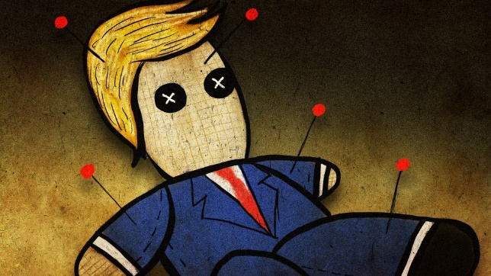

What ‘The Crucible’ can teach Donald Trump about surviving a witch hunt
Tim Rogers

“I don’t truck with no Devil!” -Tituba, Salem, Massachusetts, 1692
“NO COLLUSION…A TOTAL WITCH HUNT!” -Donald J. Trump, Washington, D.C. 2018
Donald Trump says he’s being targeted by “the single greatest witch hunt of a politician in American history.” To save himself from the cry of the villagers, the president is assembling an impressive roster of c-list lawyers.
But here’s the problem: Most modern-day criminal lawyers are out of practice when it comes to defending their clients against witch-hunting. So to help our hapless president, I turned to the wisdom of Arthur Miller’s seminal work, “The Crucible,” to see what lessons Trump might learn from the other greatest witch hunt in American history.

Donald J. Trump A TOTAL WITCH HUNT!!!
✔@realDonaldTrump 4:08 AM - Apr 10, 2018

First, I had to figure out which character from colonial Salem best represents Trump and his current predicament.
I could immediately rule out Tituba. As an enslaved Barbudan woman in Puritanical New England, Tituba only had one card to play: Confesses to witchcraft to save her life. Trump, on the other hand, epitomizes the white male privilege of the affluent colonial plantation owner. Also, he’s never confessed to anything. So Tituba is a bad match.
Next there’s Thomas Putnam, a greedy, dishonest and vindictive man who used his daughter to cry out against people whose properties he coveted. Putnam, Miller tells us, was born into a wealthy family and “regarded himself as the intellectual superior of most of the people around him.”
Despite his privilege — or perhaps because of it— Putnam was an egotistical and “deeply embittered man” who held grudges against many townspeople. Putnam used the Salem witch trials to settle old personal grievances and try to enrich himself in the process.
While there are many clear similarities between Putnam and Trump, ultimately Putnam was only an accuser, never the accused, so his example is not much help to our president.
Then there’s John Proctor. At first blush, Proctor and Trump don’t appear to have much in common. Miller describes Proctor as a serious and respected man — a hardworking farmer with a “steady manner” and a “quiet confidence.” If anything, John Proctor appears to be the antithesis of Donald Trump.
But as the play unfolds, some similarities between the two men begin to reveal themselves. In Act Two, we learn that Proctor’s home life is somewhat stormy. The good farmer has cheated on his wife with a younger temptress named Abigail Williams, who later becomes his principal accuser in court.
As the witch hunt intensifies, Proctor, like Trump, feels increasingly exasperated as he struggles to defend himself against FAKE NEWS accusations hurled at him by a bitter former lover. He views the whole proceeding as “a whore’s vengeance” against him and his wife.
“Vengeance is walking Salem. We are what we always were in Salem, but now the little crazy children are jangling the keys of the kingdom, and common vengeance writes the law!” Proctor says, while ripping-up a court warrant.
But Proctor doesn’t get off the hook that easily. The deep state is determined to make an example of him for refusing to cooperate with their inquiry.
“Now we shall touch the bottom of this swamp,” Deputy Governor Danforth says while interrogating Proctor about his “crime of lechery.”
Proctor’s taciturn farmer routine belies a complicated man. At the end of Act Four, he confesses before the judge to binding himself to do the devil’s service, but then refuses to sign his confession. Proctor also refuses to bear witness against his friends and neighbors who are similarly accused of witchcraft. “I speak my own sins; I cannot judge another. Crying out, with hatred: I have no tongue for it.”
This is where any similarity between the cases of Proctor and Trump ends. Proctor ultimately goes to gallows to defend his friends and family name. As much as Trump cherishes his own brand name, it’s difficult to imagine the president willfully climbing the scaffold steps to save his family’s reputation or spare his neighbors. Trump is no hero or martyr.
“Because it is my name! Because I cannot have another in my life! Because I lie and sign myself to lies! Because I am not worth the dust on the feet of them that hang! How may I live without my name? I have given you my soul; leave me my name!”
- - JOHN PROCTOR ON REFUSING TO SPARE HIS OWN LIFE BY SIGNING HIS CONFESSION.
So we still haven’t found anything in the play to help Trump’s defense strategy. He wouldn’t confess like Tituba, and wouldn’t “go like a saint” to the gallows like Proctor. But there is one last example: Mary Warren, the girl who gets accused of witchcraft then defends herself by deflecting blame on Proctor.
When Mary Warren was backed into the corner, she went on the offensive, projecting her alleged crime onto others. Trump is Mary Warren.
“There was collusion with the Russians and the Democrats. A lot of collusion… There was tremendous collusion on behalf of the Russians and the Democrats.”- President Trump in an interview with the New York Times.
Trump, like Mary Warren, instinctively knows that the best way to survive a witch hunt is to cross the courtroom from accused to accuser and blame others of the same crime. If someone points at you, you point at someone else.
So the best advice I could find for Donald Trump in “The Crucible” is to team up with Goody Daniels and accuse Mike Pence of dancing naked in the forest with the devil.
DO YOU AGREE OR DISAGREE WITH WHO THE CRUCIBLE COMPARES DONALD TRUMP TO?
Answer in 3-4 sentences WITH an explanation of why…

